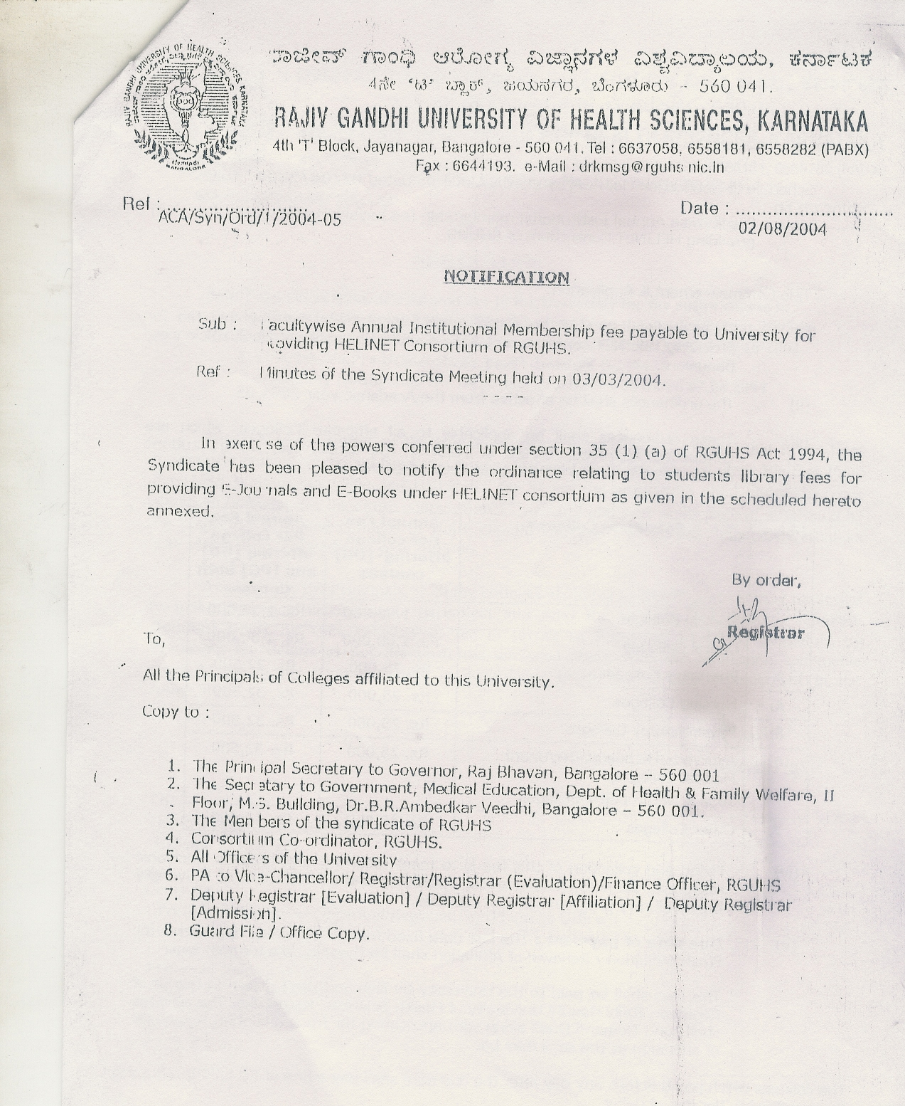

Schedule to Notification No.ACA/Syn/Ord/1/2004-05 dated 02/08/2004

Sub: Faculty wise Annual institutional membership fee payable to University for providing HELINET consortium of RGUHS.

Title Commencement & Application:

- These ordinance shall be called annual institutional membership fee for providing HELINET consortium of Rajiv Gandhi University of Health Sciences, Bangalore.
- The ordinance shall be effective from the Academic year 2004-05.
- These ordinance shall be applicable to all affiliated colleges, which are conducting approved courses of RGUHS. The faculty wise, an institutions annual fee payable
to RGUHS is as detailed below.

Sl. No. | Faculties-Colleges | Annual Fee per College offering (UG) courses | Annual Fee per College offering (UG) & (PG) both courses
1 | Medical colleges | Rs.1,00,000 | Rs. ,1,30,000
2 | Dental colleges | Rs.1,00,000 | Rs. ,1,30,000
3 | Pharmacy colleges | Rs. 25,000 | Rs. 32,500
4 | Nursing colleges | Rs. 25,000 | Rs. 32,500
5 | Physiotherapy colleges | Rs. 25,000 | Rs. 32,500
6 | Ayurveda /Homeopathy/Unani Medical colleges | Rs. 25,000 | Rs. 32,500
7 | Other colleges | Rs. 10,000 | Rs.13,000

- Fixing and collection of this fee is to meet recurring cost towards electronic resources, services, maintenance, upgrading and development of University Digital Library programmes and activities.
- Due date of Payment: The last date fixed for submission of Application for Fresh
Affiliation / Renewal of Affiliation shall be the due date for payment.
This fees shall be paid to the university by demand draft drawn in favour of Registrar, Rajiv Gandhi University of Health Sciences, Karnataka. The colleges shall send demand draft along with application for fresh affiliation & renewal of affiliation as the case may be.
The colleges which pay this fees any day after the due date shall pay a fine of Rs.1,000/-( Rupees One thousand only) per day of delay.

